**DATA TYPES AND DATA OBJECTS**

**INPUT:**

**OUTPUT:**

**STRINGS**

**INPUT:**

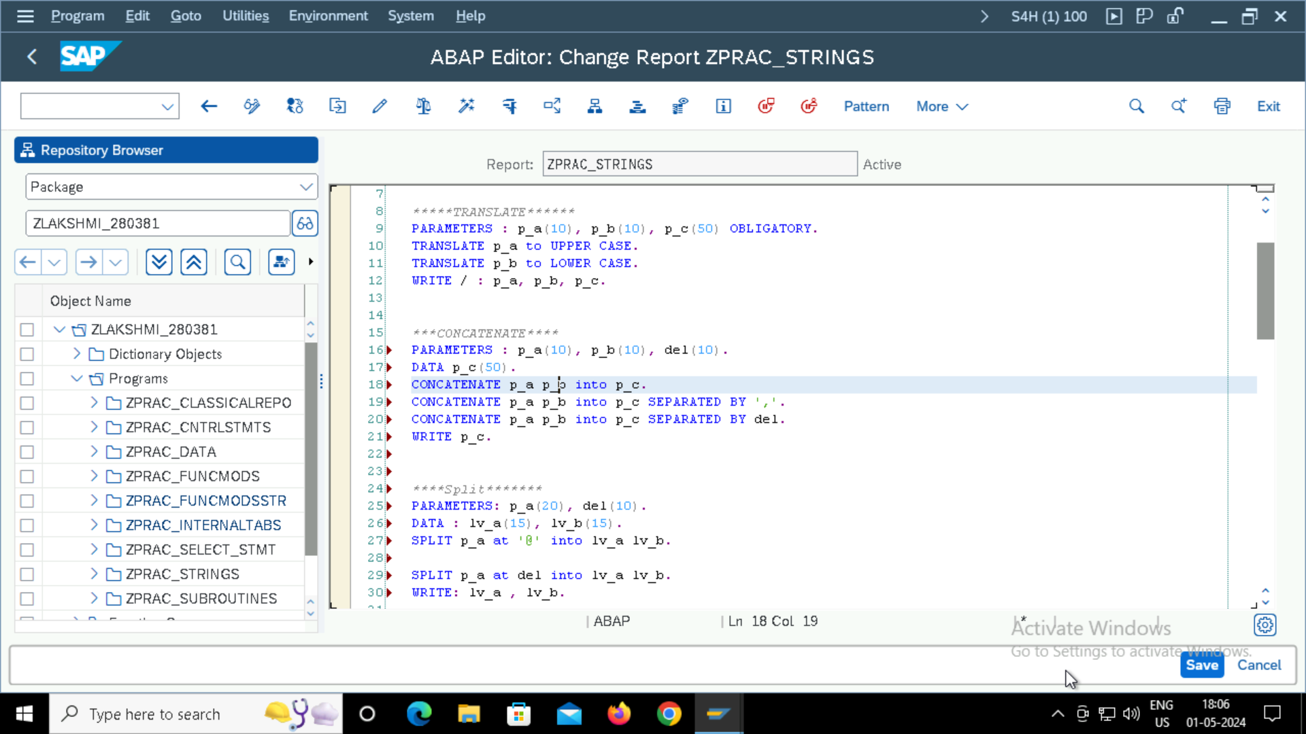

**OUTPUTs:**

**TRANSLATE,**

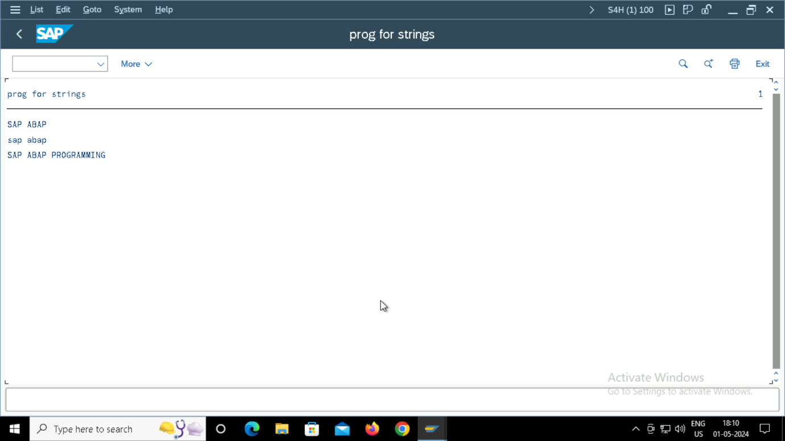

**CONCATENATE and using separated by,**

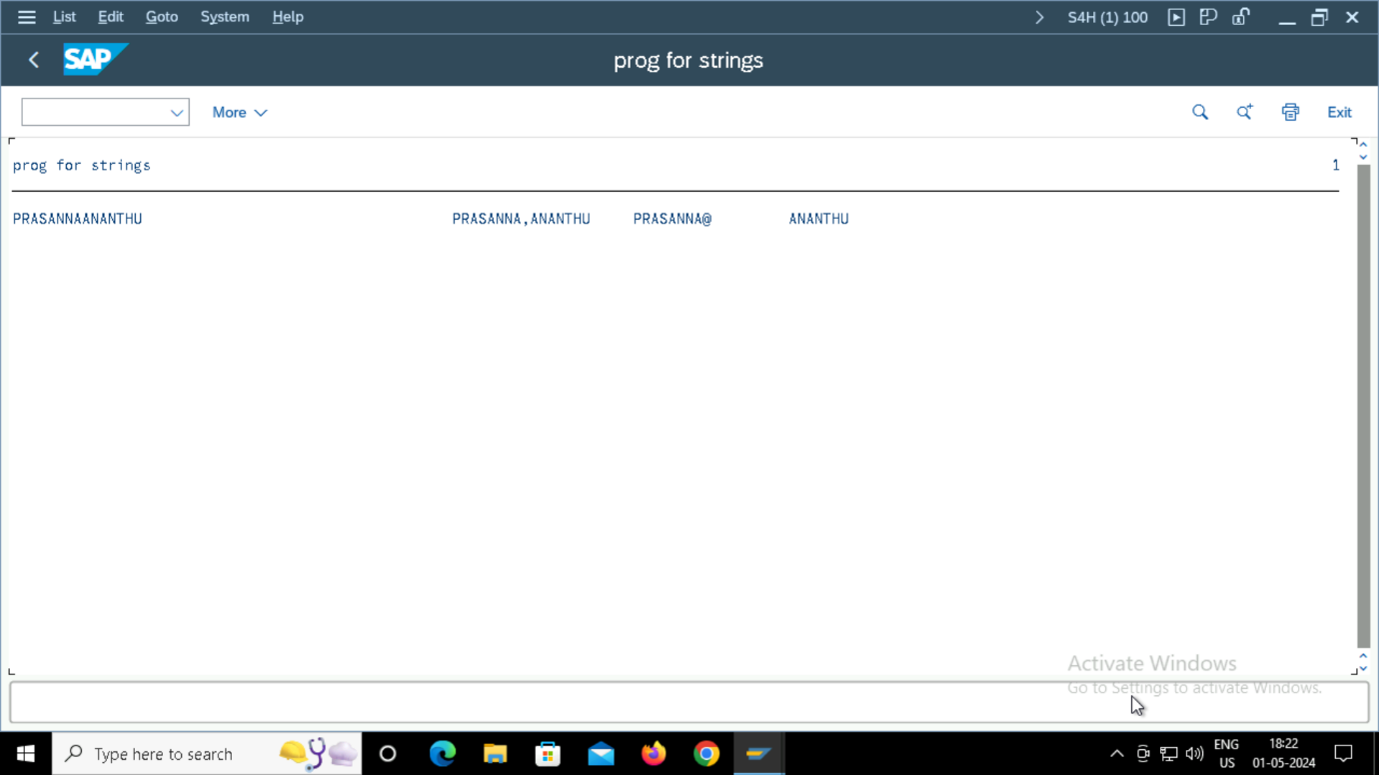

**SPLIT,**

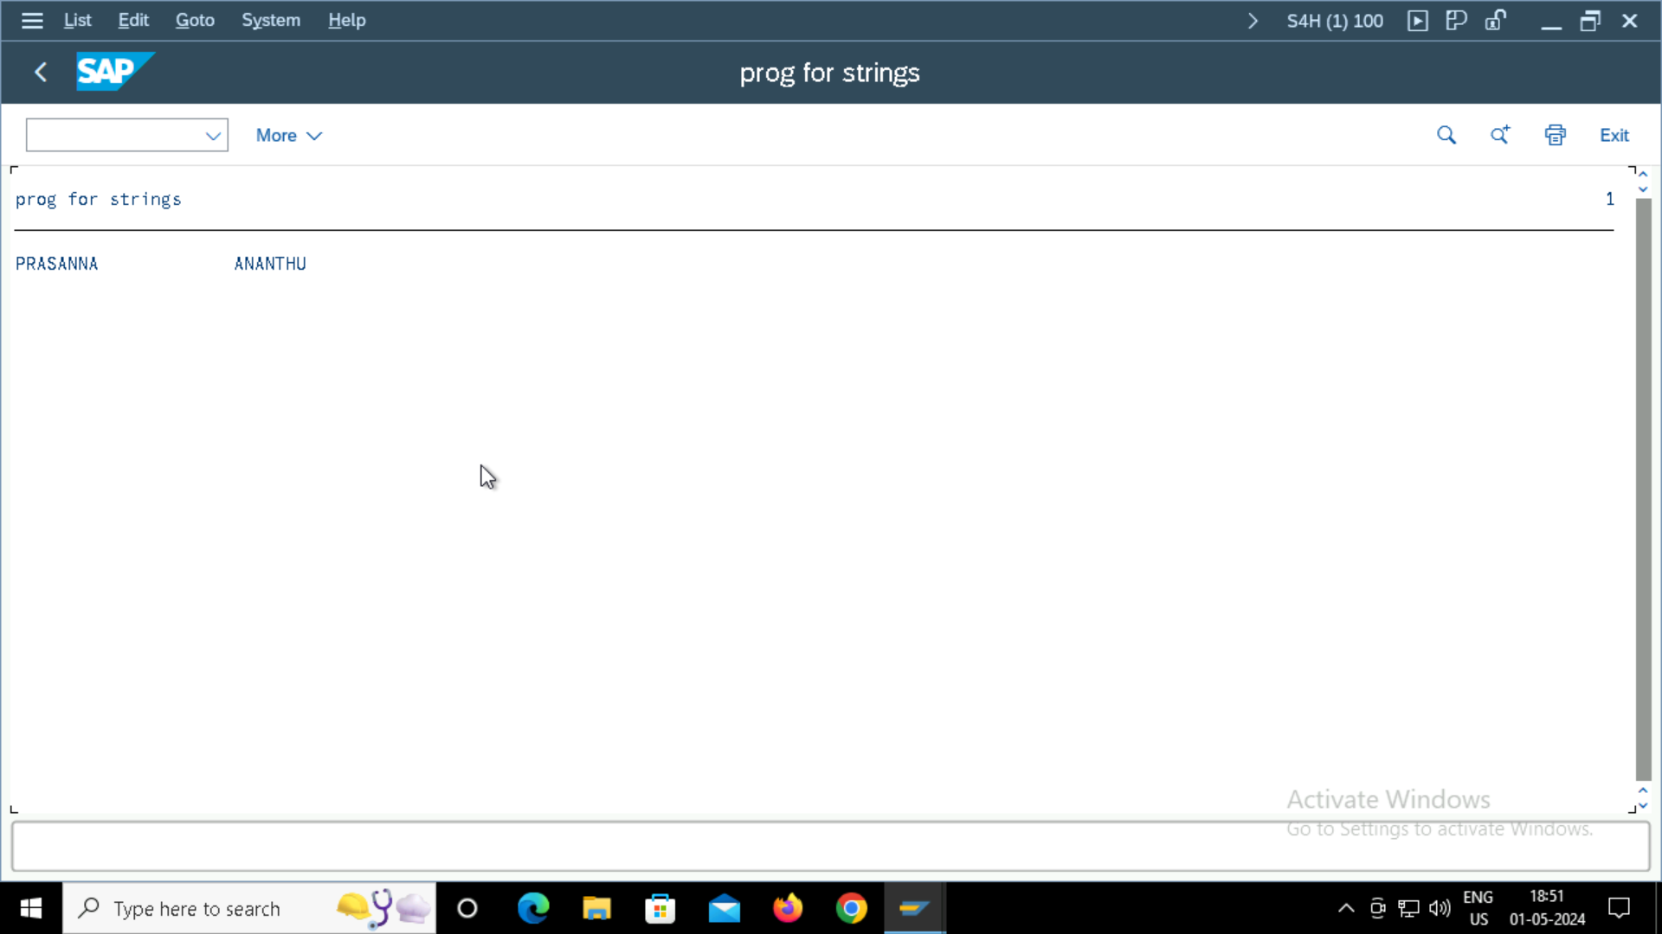

**OFFSETTING,**

**STRING LENGTH,**

**REPLACE,**

**CONDENSE and with NOGAPS,**

**LEFT SHIFT and RIGHT SHIFT,**

**CONTROL STATEMENTS , LOOP STATEMENTS and LOOP TERMINATING STATEMENTS**

**INPUTS,**

**OUTPUTS for control statements and loops,**

**LOOP TERMINATING STATEMENTS INPUT,**

**OUTPUT,**

**SELECT STATEMENTS,**

**INPUTs**

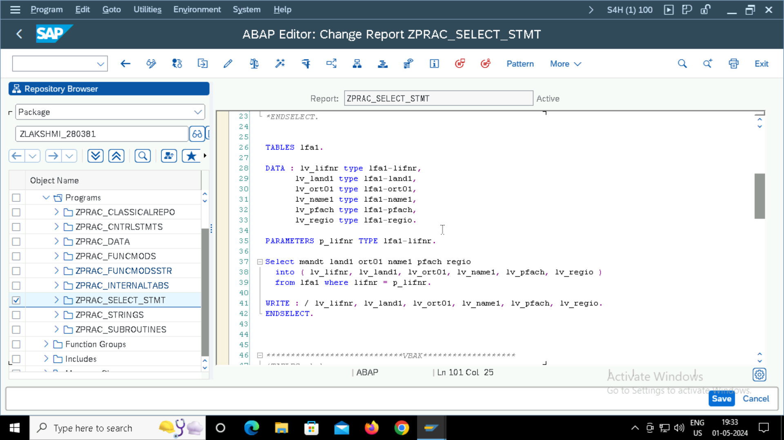

**OUTPUT,**

**TABLES,**

**EMPLOYEE TABLE:**

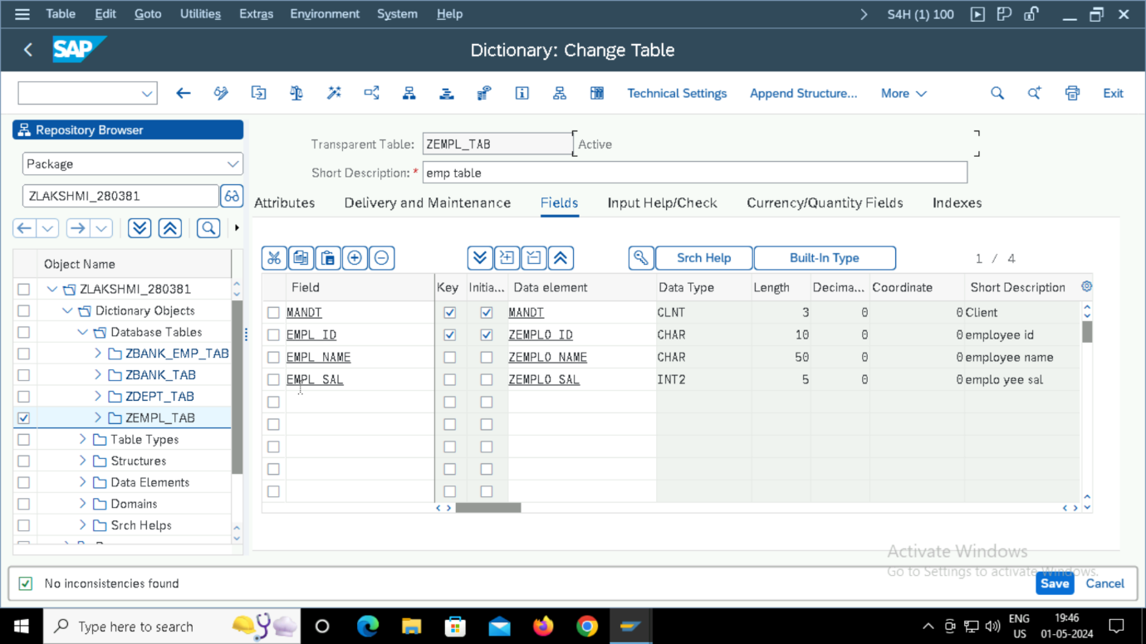

**EMPLOYEE ID is the foreign key in the DEPARTMENT TABLE,**

**STRUCTURES**

**Creating flat structure,**

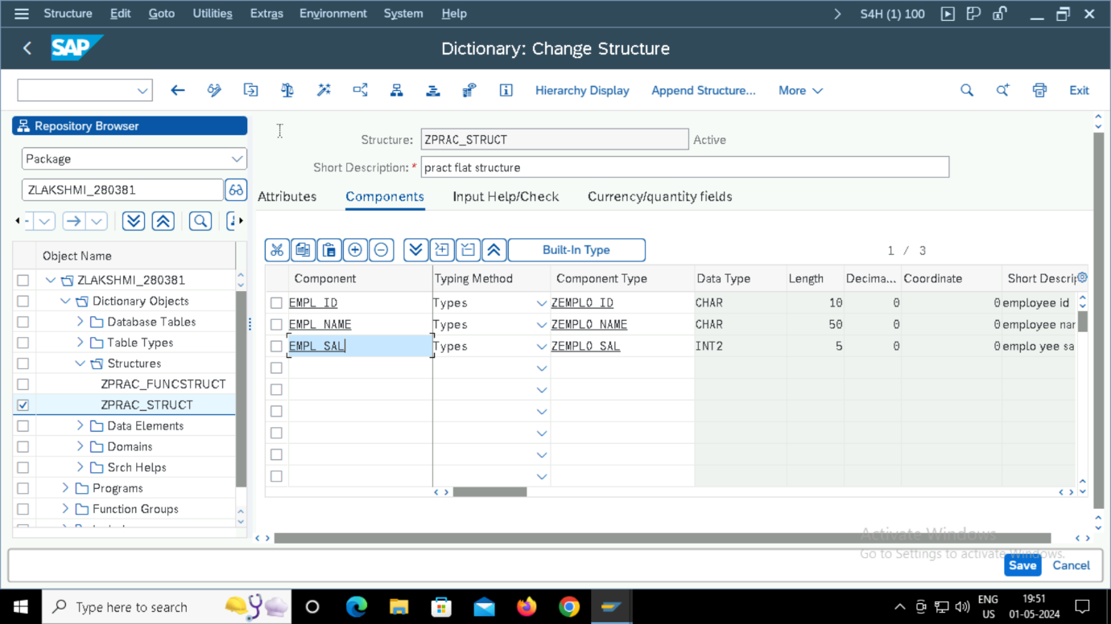

**Creating complex structure: after creating flat structure, we need to create complex structure using table type.**

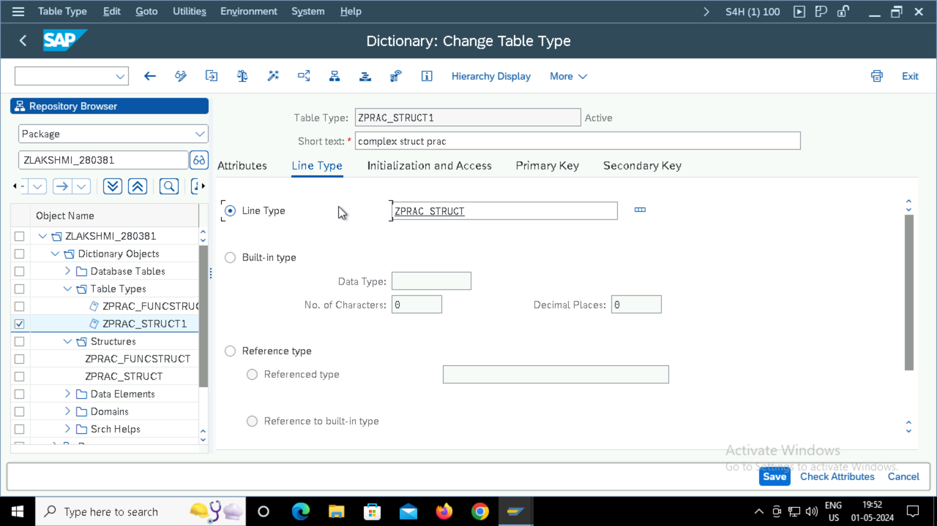

**SEARCH HELPS**

**INTERNAL TABLES**

**INPUT,**

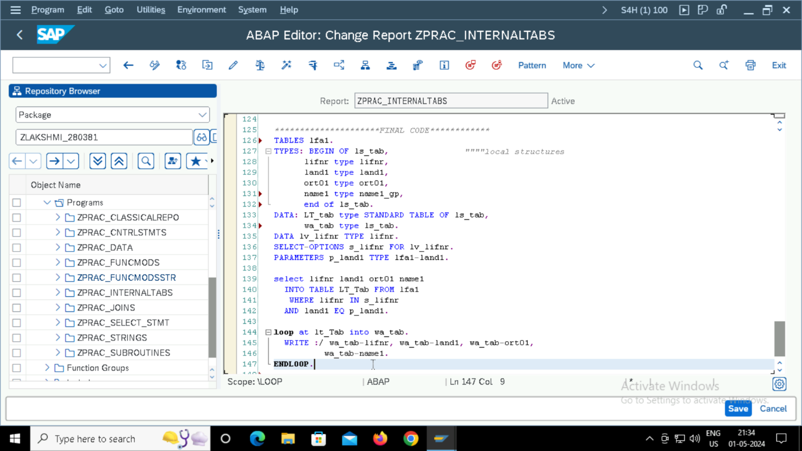

**OUTPUT,**

**VIEWS**

**DATABASE VIEWS,**

**INPUT**

**OUTPUT,**

**JOINS,**

**INPUT,**

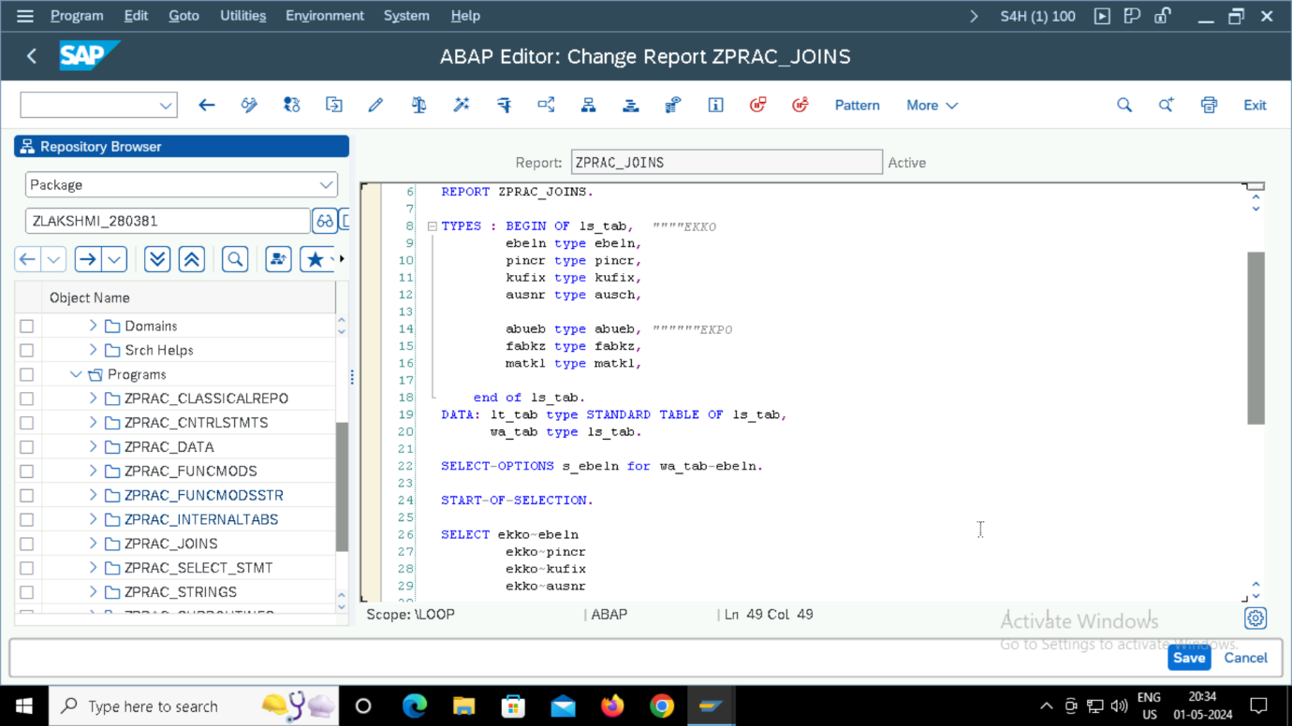

**OUTPUT**

**FORMATTING**

**INPUTs,**

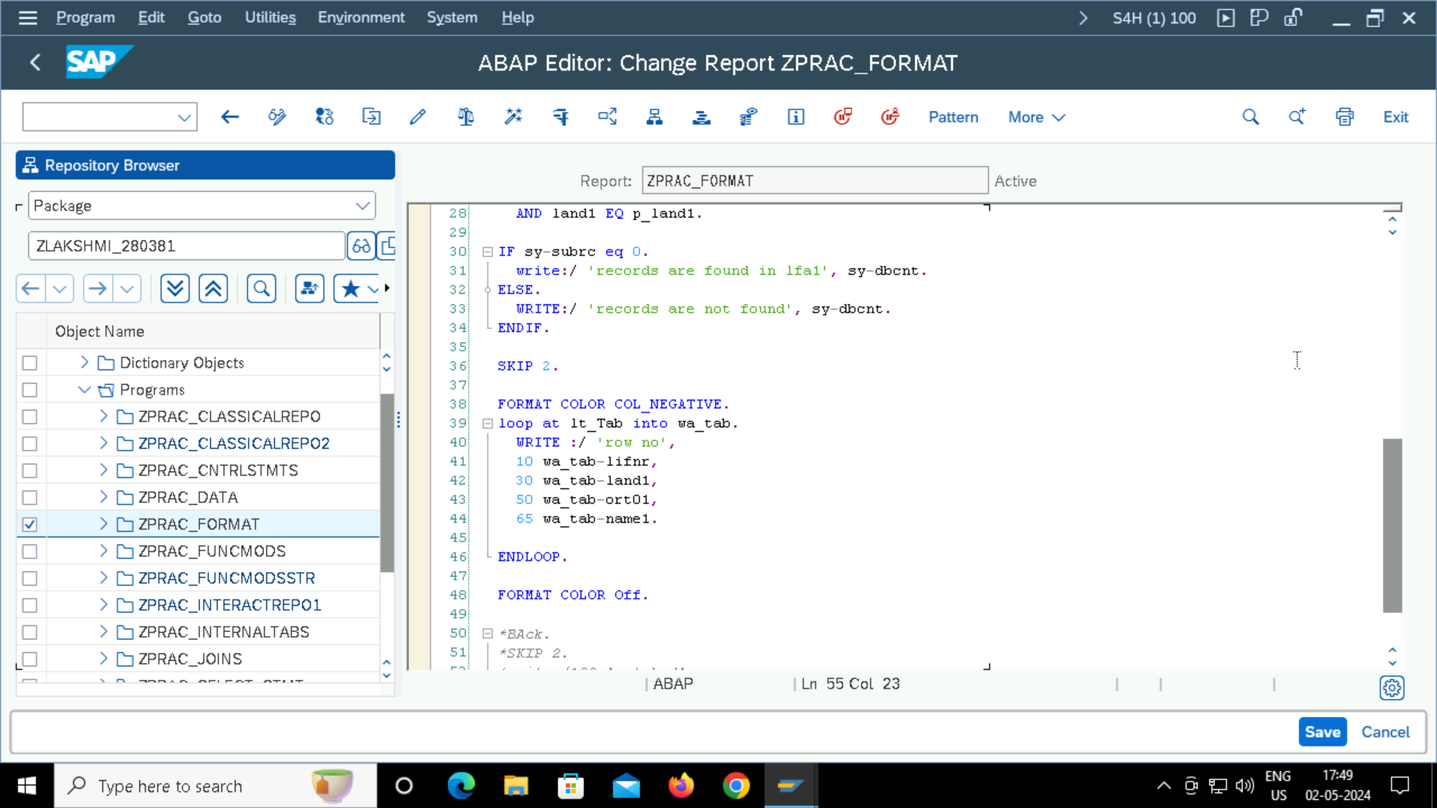

**Outputs,**

